California State University, Los Angeles
Annual Assessment Report: Undergraduate Degree Programs

Program: COMPUTER SCIENCE BACHELOR OF SCIENCE
Report Semester/Year: FALL 2020

College/School: ECST Assessment Coordinator: Dr. CHENGYU SUN

Specialized Accreditation: No Yes please specify Agency/organization and Date ABET (ACCREDITED to 2023)

Department Mission:
To graduate well educated computer scientists who are prepared to meet the challenges of a rapidly changing, increasingly complex world. This will be accomplished through:
- A well-qualified faculty who care about students and their success.
- A dynamic, up-to-date curriculum that has an optimal balance between theory and practice.
- Laboratories, computer facilities, and instructional classrooms on par with any computer science program in the nation.
- Unique co-curricular opportunities for students such as participation in student design competitions, professional student organizations, and pre-professional employment.
- Opportunities for undergraduate and graduate students to participate in research and industry-funded design clinic projects.
- Mutually beneficial partnerships with area industry that take advantage of our location in one of the most concentrated high-tech centers in the nation.
- Strong cooperative relationships with local high schools, community colleges, and with other four-year institutions.

Year revised: 2005

Program Learning Outcomes (PLOs):
Please list all the PLOs and when they were last assessed or plan on being assessed (see attached reference sheet for a rubric with PLO guidelines):

The Accreditation Board for Engineering and Technology (ABET) Commission has engaged the computing community to modify and update these criteria. These recent changes to the Computer Science program criteria primarily impact student outcomes (what program graduates are expected to know and be able to do by graduation) and curriculum. The new outcomes from ABET has also been adopted by the Computer Science Bachelor of Science program here at CSULA. The new outcomes are:

PLOs | When did you last assess it or plan on assessing it?
- Analyze a complex computing problem and to apply principles of computing and other relevant disciplines to identify solutions. | Fall 2019
- Design, implement, and evaluate a computing-based solution to meet a given set of computing requirements in the context of the program’s discipline. | Spring 2020
- Communicate effectively in a variety of professional contexts. | Spring 2020
- Recognize professional responsibilities and make informed judgments in computing practice based on legal and ethical principles. | Spring 2020
- Function effectively as a member or leader of a team engaged in activities appropriate to the program’s discipline. | Spring 2020
- Apply computer science theory and software development fundamentals to produce computing-based solutions. | Spring 2020

These new outcomes replace our old outcomes listed below.
- Students will be able to apply concepts and techniques from computing and mathematics to both theoretical and practical problems.
- Students will be able to demonstrate fluency in at least one programming language and acquaintance with at least three more.
- Students will have a strong foundation in the design, analysis, and application of many types of algorithms.
- Students will have a fundamental understanding of computer systems.
- Students will have the training to analyze problems and identify and define the computing requirements appropriate to their solutions.
- Students will have the training to design, implement, and evaluate large software systems working both individually and collaboratively.
- Students will be able to communicate effectively orally and in writing.
- Students will have the knowledge, skills, and attitudes for lifelong self-development.
- Students will have the ability to analyze the local and global impact of computing on individuals and society.
- Students will have a fundamental understanding of social, professional, ethical, legal, and security issues in computing.

Alignment of Institutional Learning Outcomes (ILOs) and PLOs:
Please indicate which of your PLOs best match the following ILOs. (see attached reference sheet for a complete description of each ILO)

Cal State LA Institutional Learning Outcomes: Undergraduate | PLO(s) which match this ILO
- Knowledge: Mastery of content and processes of inquiry | 1, 2, 6
- Proficiency: Intellectual skills | 2, 3
- Place and Community: Urban and global mission | 4, 5
- Transformation: Integrative learning | 4, 5, 6

Assessment Results
Describe any assessment activities conducted in AY 2019-20 for each outcome. See attached reference sheet for examples of assessment measures and use of results, and rubrics which will be used to evaluate your assessment processes. Please attach any additional information as needed.
Program Learning Outcome  (List activities for each PLO. Enter “general” for activities that pertain to multiple PLOs) | 1. How and when was this PLO assessed? (For example, which assessments were used, which courses were examined, what were the dates of data collection?) See Reference sheet for other examples | 2. What were the results? (For example, how many students reached each level of proficiency on the SLOs assessed?) See Reference sheet for other examples | 3. Based on the results, what instructional, programmatic, or curricular improvements were made?

- Analyze a complex computing problem and to apply principles of computing and other relevant disciplines to identify solutions.
(a) Assessment Measures
- Rubric: Software Engineering – Analysis (in CS 3337 and CS 4961)
- Survey
(b) Dates of Assessment
This is a transition year for us as we migrate from the old outcomes to the new ones. Surveys were conducted in Fall 2019 using the new outcomes, but some rubrics such as Software Engineering – Analysis were not developed until Fall 2020. We expect a full assessment with the new outcomes and measure in the 2020-2021 academic year.
(c) Assessment Results
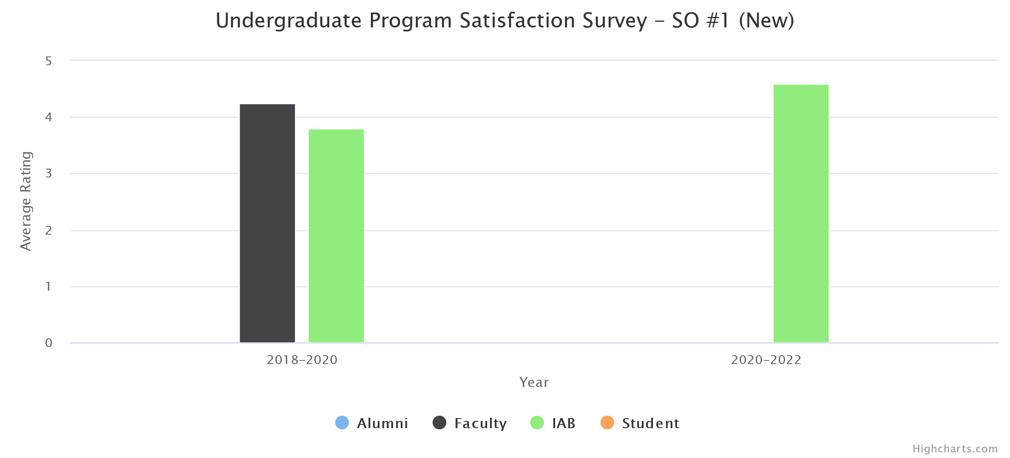
(d) Changes Made
No instructional, programmatic, or curricular changes were made as the survey results met our target of 3 or higher.
- Design, implement, and evaluate a computing-based solution to meet a given set of computing requirements in the context of the program’s discipline.
(a) Assessment Measures
- Rubric: Software Engineering - Design (Ver 2.0) (in CS 3337 and CS 4962)
- Rubric: Software Engineering - Implementation (Ver 2.0) (in CS 3337 and CS 4962)
- Rubric: Software Engineering – Evaluation (in CS 337 and CS 4962)
- Survey
(b) Dates of Assessment
This is a transition year for us as we migrate from the old outcomes to the new ones. Surveys were conducted in Fall 2019 using the new outcomes, but some rubrics such as Software Engineering – Evaluation were not developed until Fall 2020. We expect a full assessment with the new outcomes and measure in the 2020-2021 academic year.

(c) Assessment Results

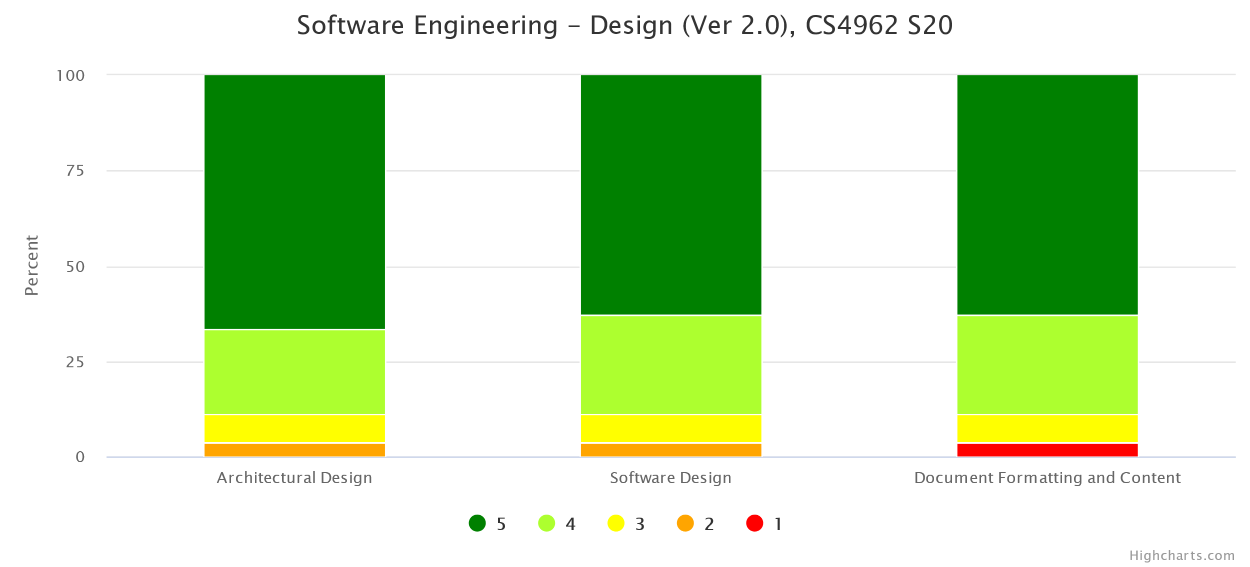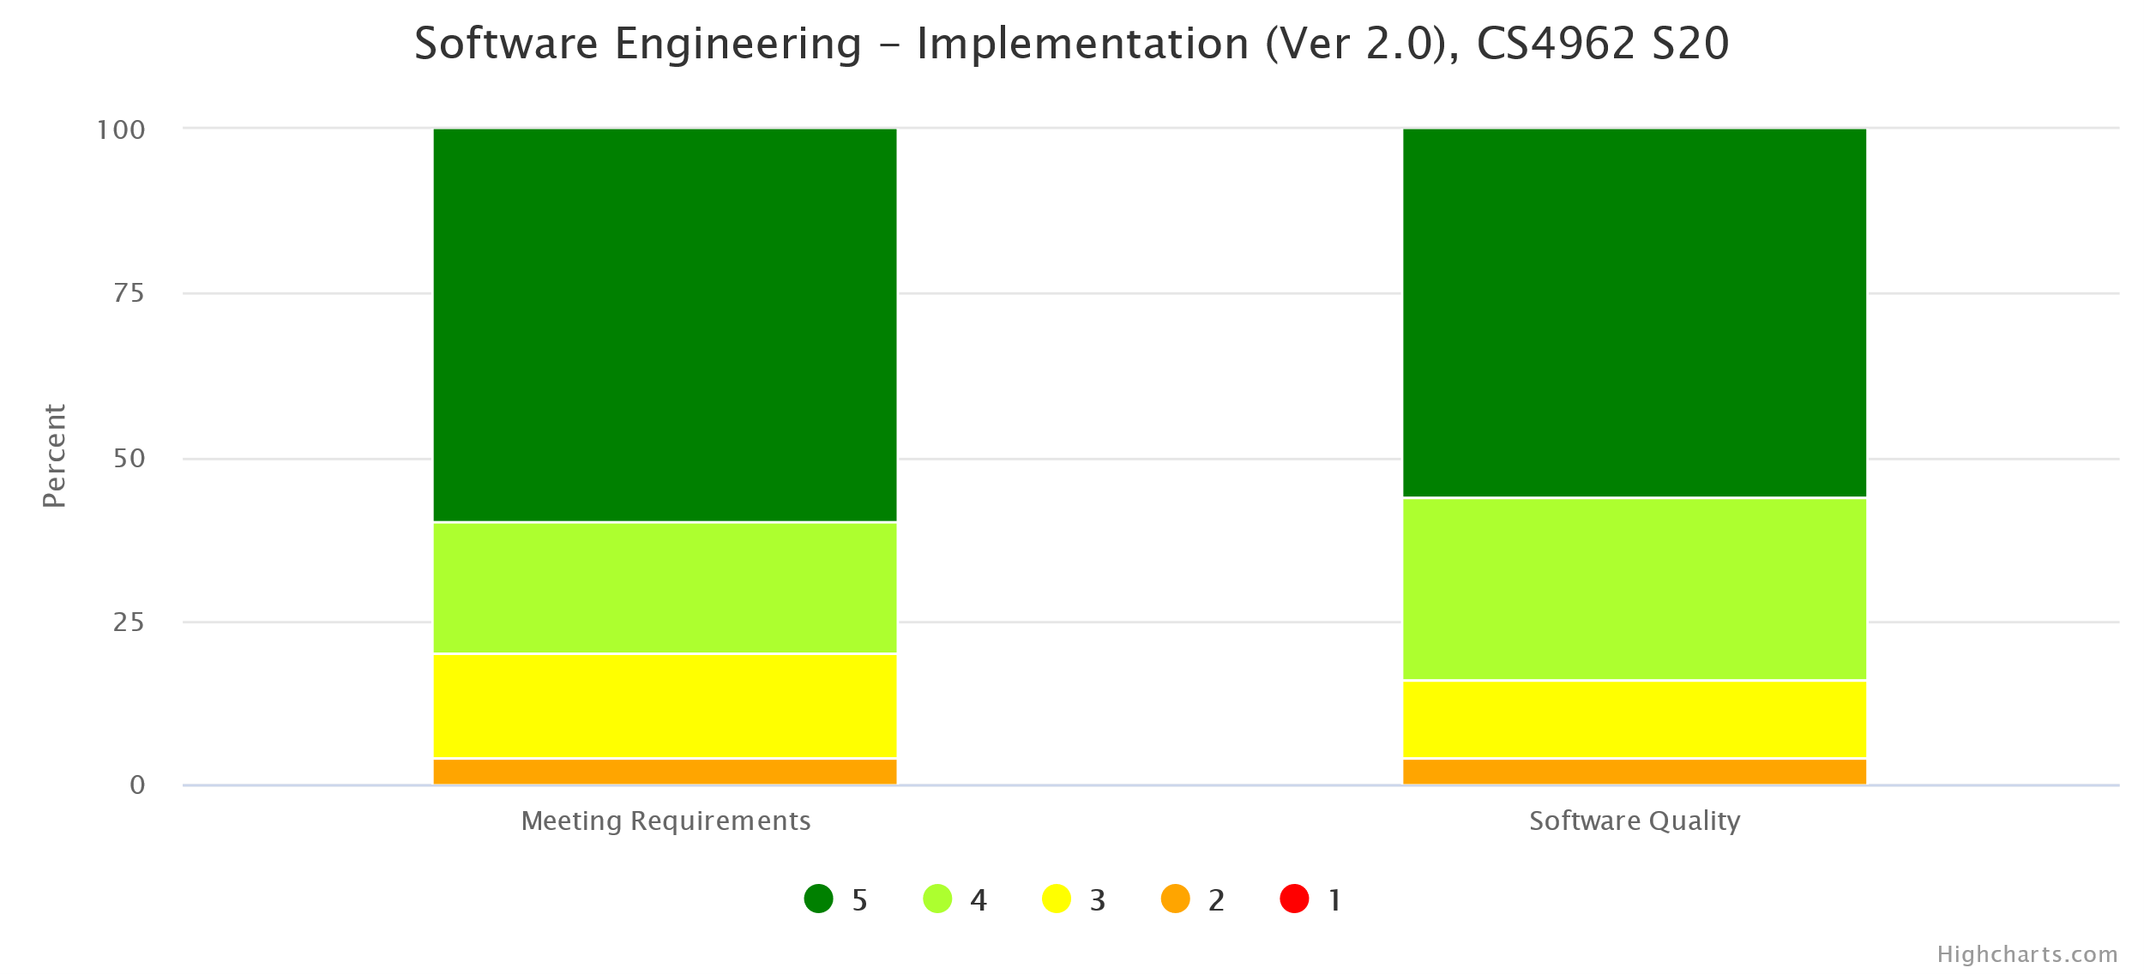
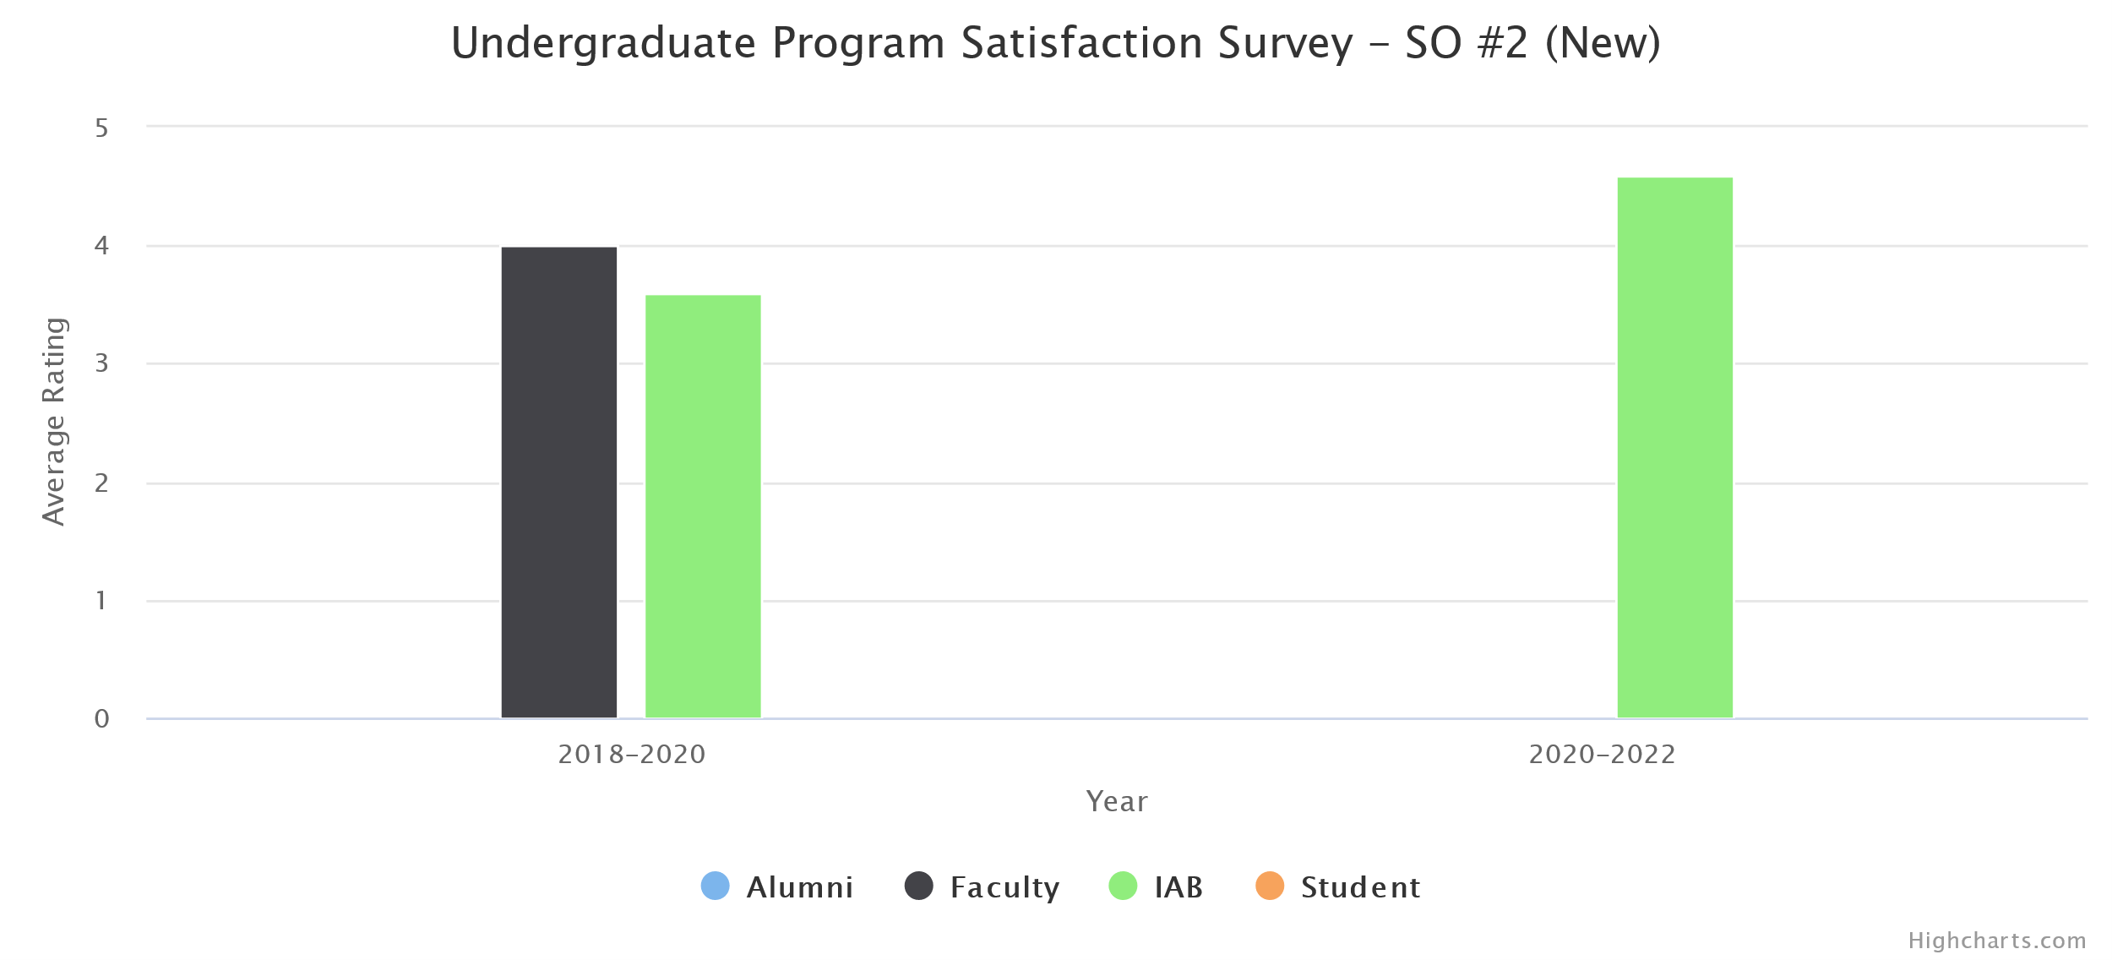
(d) Changes Made
No instructional, programmatic, or curricular changes were made as both rubric assessment and the survey results met our target thresholds.
- Communicate effectively in a variety of professional contexts.
(a) Assessment Measures
- Rubric: Oral Communication (Ver 2.0) (in CS 3337, CS 4961, CS 4962)
- Rubric: Written Communication (Ver 2.0) (in CS 3337, CS 4961, CS 4962)
- Survey
(b) Dates of Assessment
- Rubric: Oral Communication (Ver 2.0)
  - Fall 2019 in CS 4961
  - Spring 2020 in CS 3337, CS 4962
- Rubric: Written Communication (Ver 2.0)
  - Fall 2019 in CS 4961
  - Spring 2020 in CS 4962
- Survey: Fall 2019
(c) Assessment Results
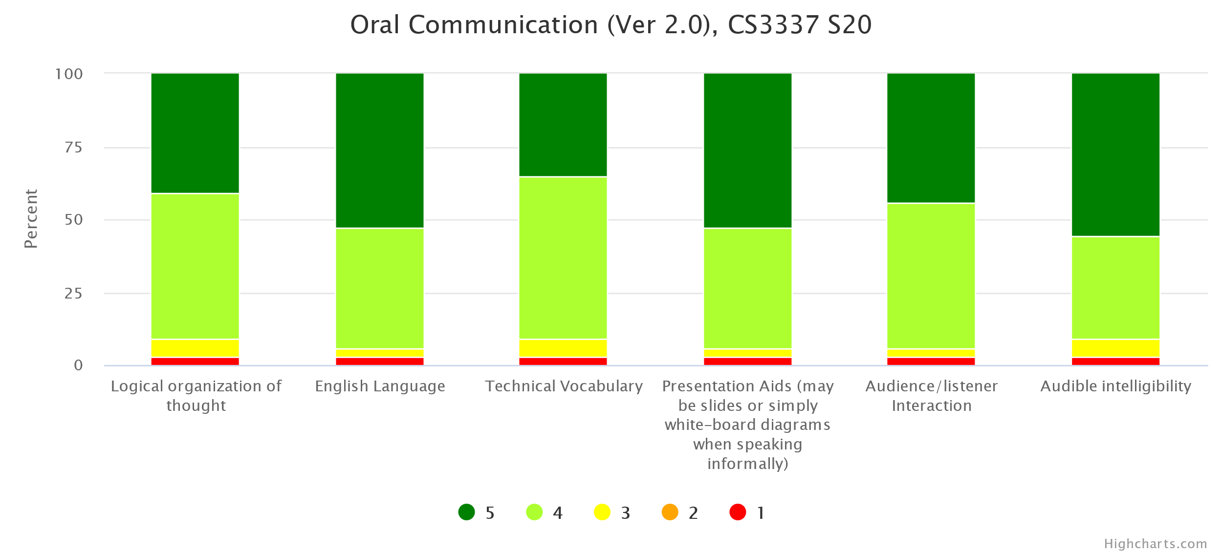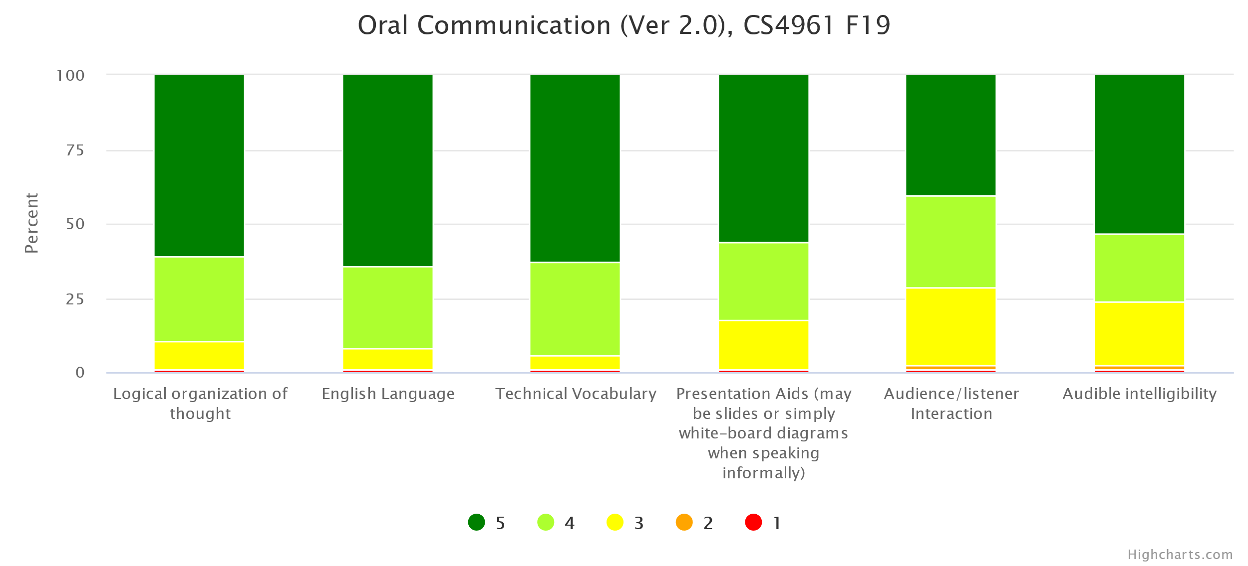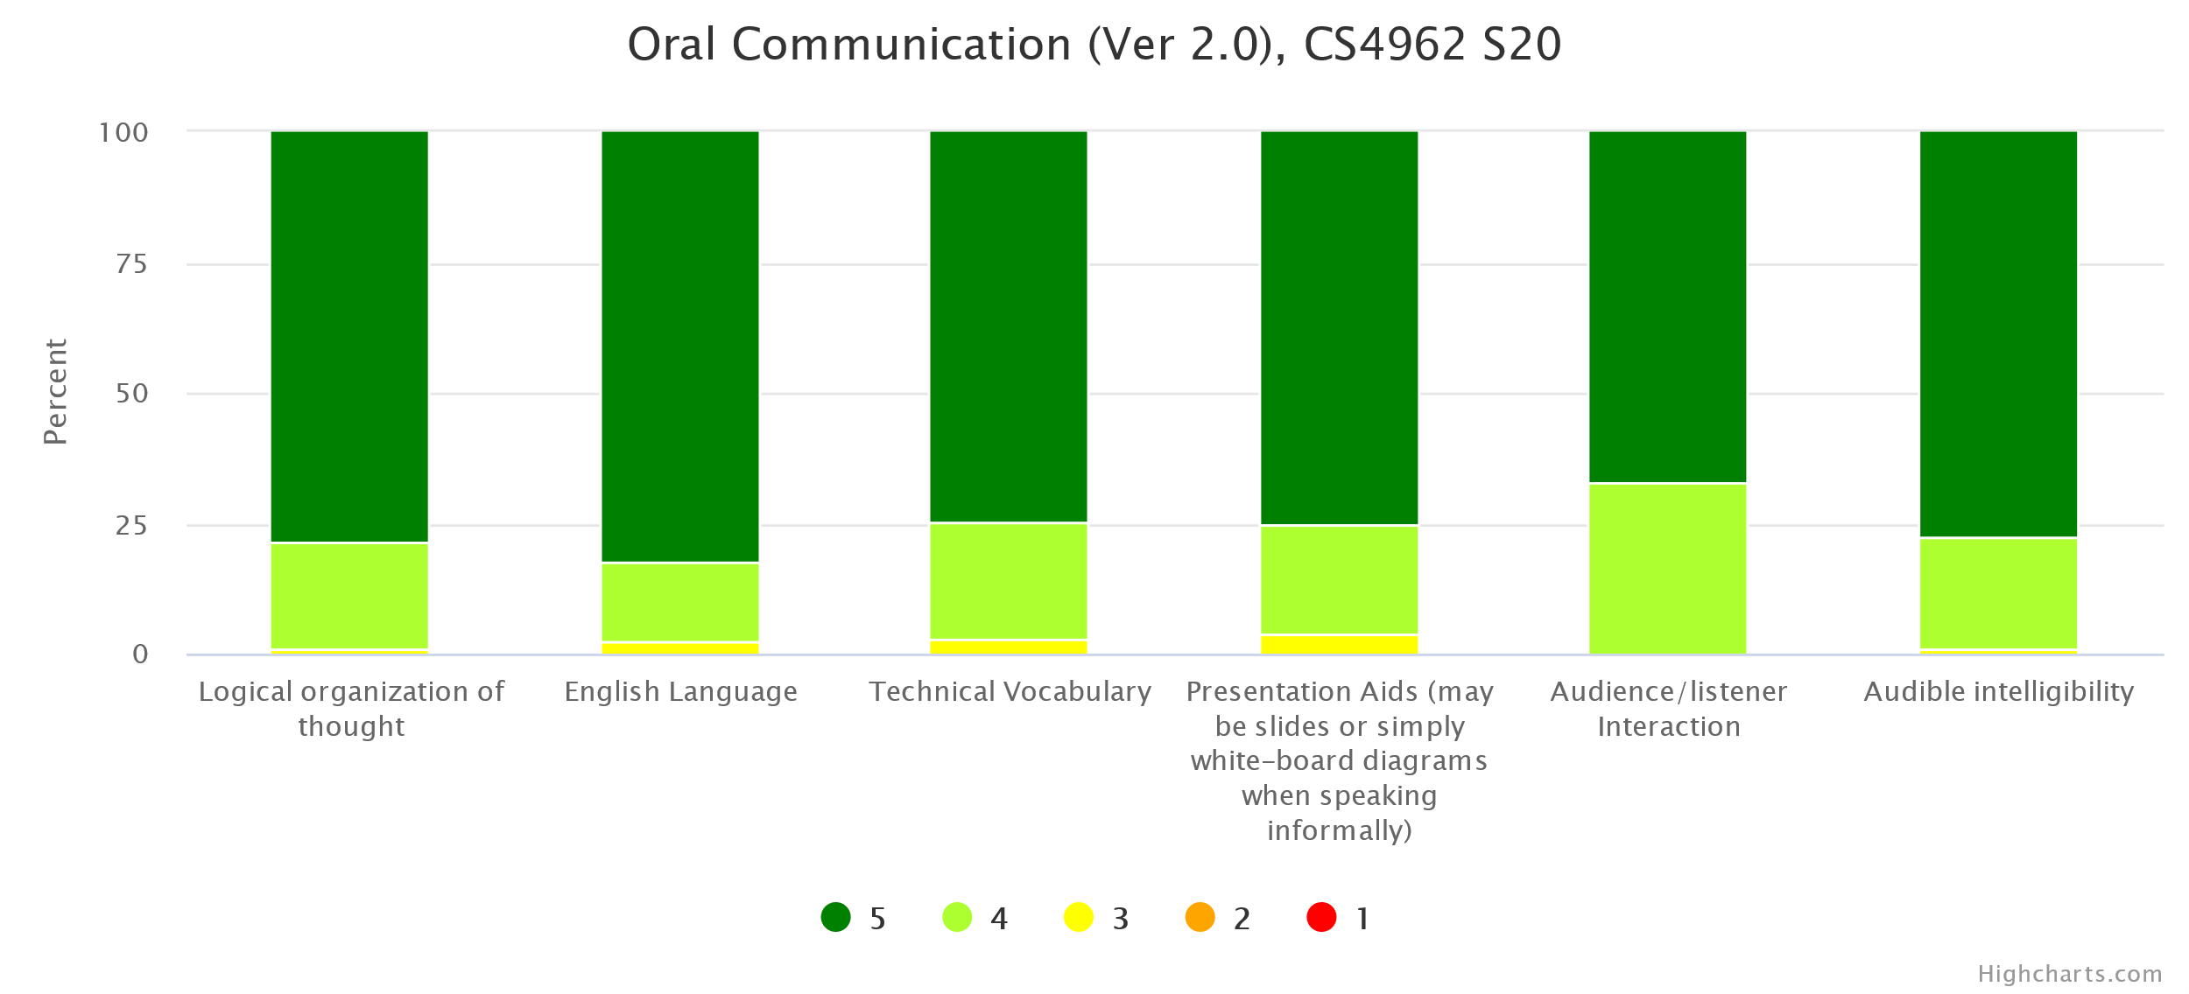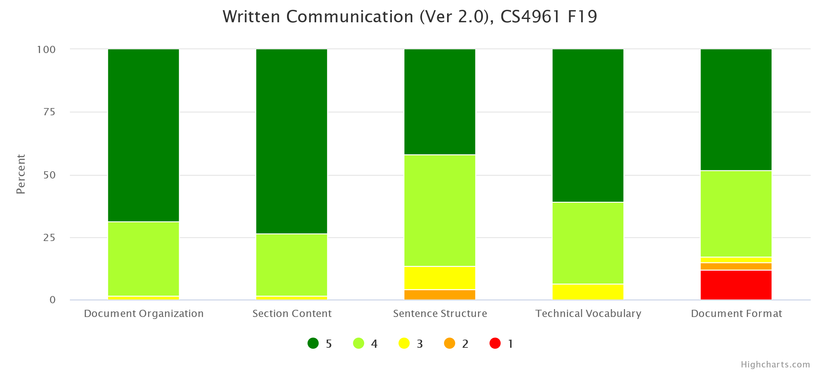
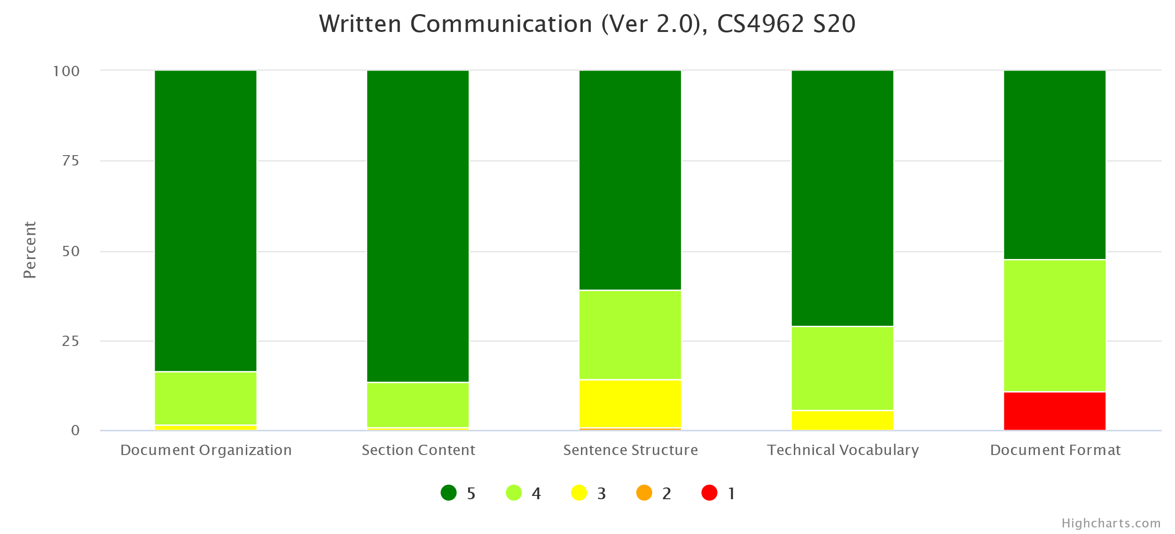
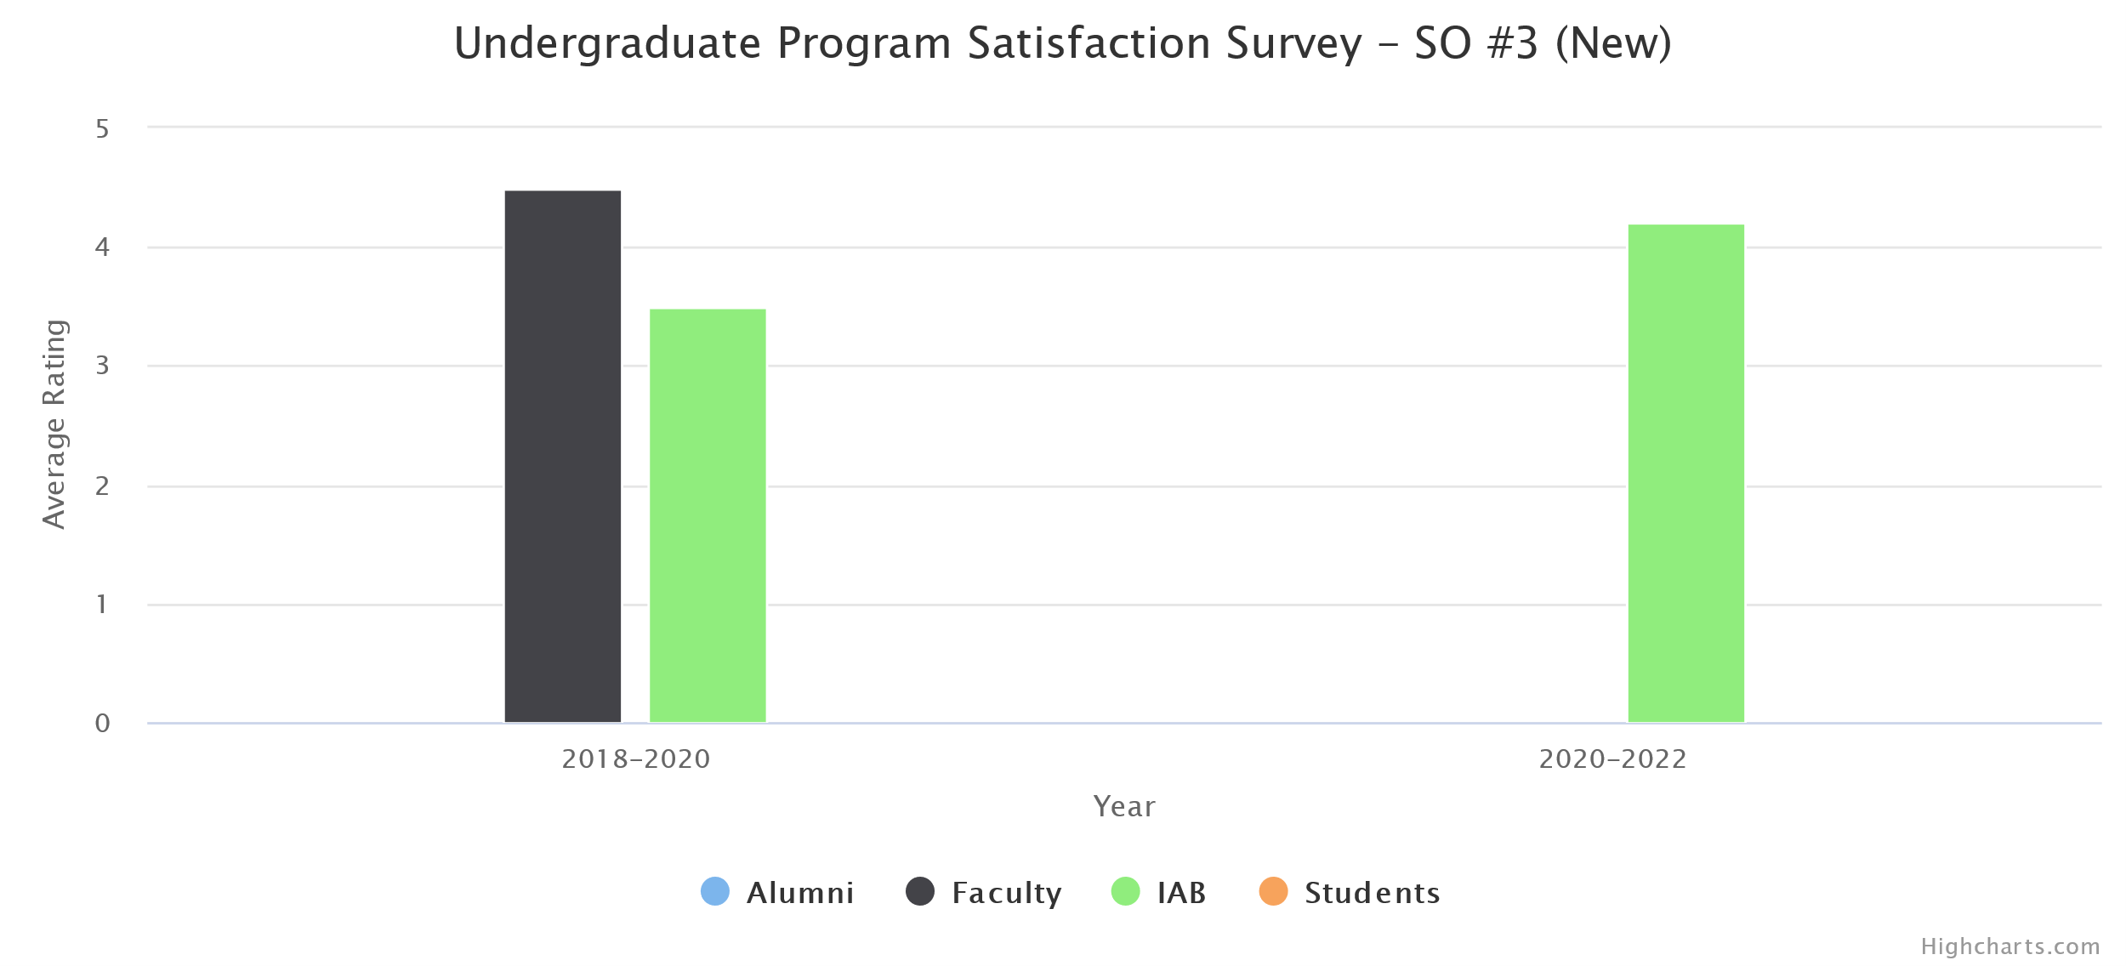
(d) Changes Made
No instructional, programmatic, or curricular changes were made as both rubric assessment and the survey results met our target thresholds.

- Recognize professional responsibilities and make informed judgments in computing practice based on legal and ethical principles.
(a) Assessment Measures
- Rubric: Ethics in the Computer Age (Ver 3.0) (in CS 3801, CS 4962)
- Survey
(b) Dates of Assessment
- Rubric: Ethics in the Computer Age (Ver 3.0)
  - Spring 2020 in CS 3801
- Survey: Fall 2019
Ethics in the Computer Age (Ver 3.0) is a new rubric developed for the new outcomes. Previously it was assessed only in CS 3801. This semester the department has decided to assess it also in CS 4962.

(c) Assessment Results
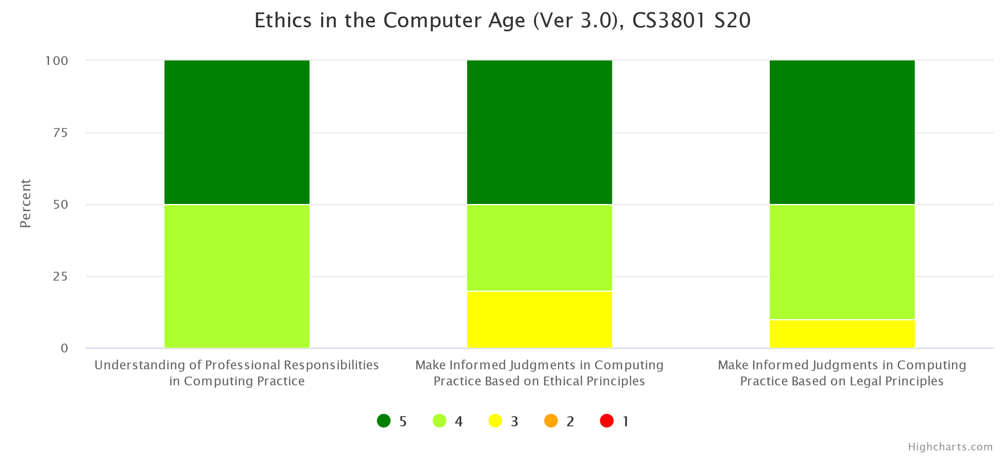
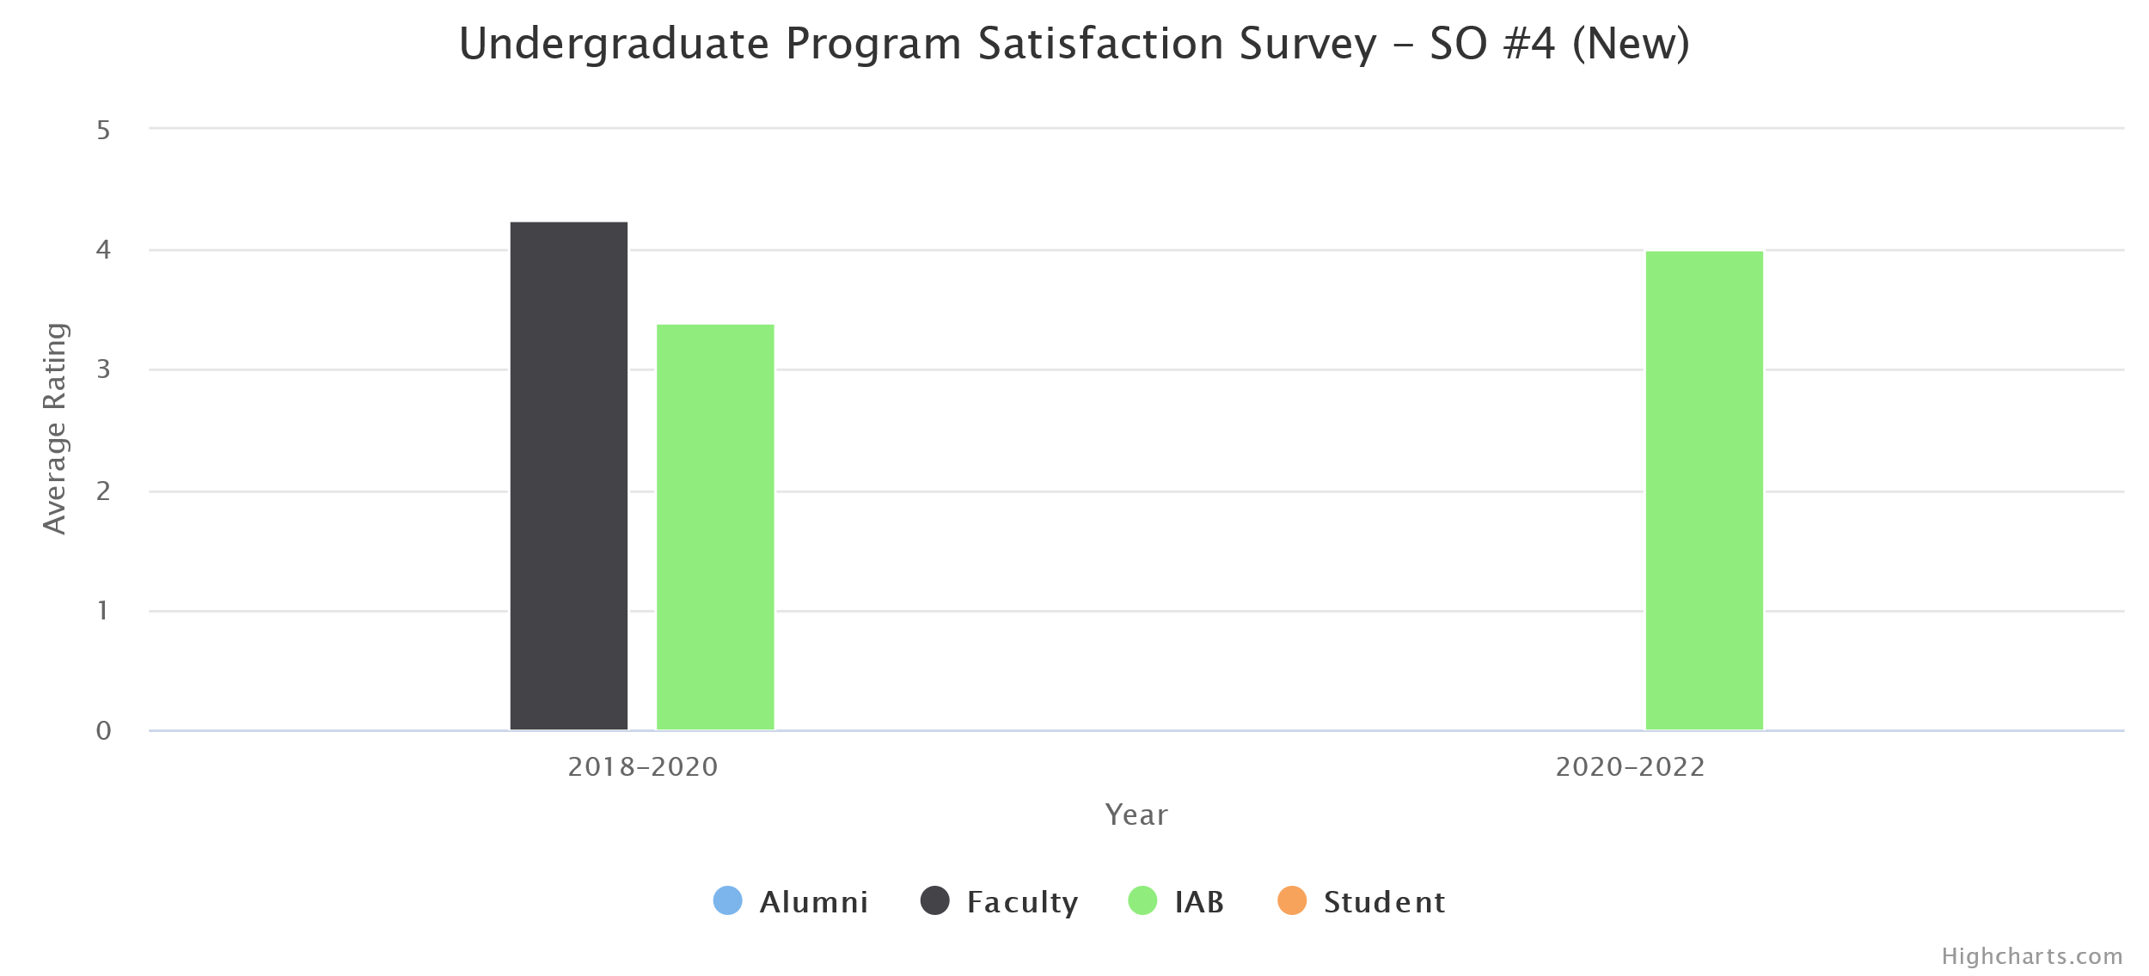
(d) Changes Made
No instructional, programmatic, or curricular changes were made as both rubric assessment and the survey results met our target thresholds.
- Function effectively as a member or leader of a team engaged in activities appropriate to the program’s discipline.
(a) Assessment Measures
- Rubric: Teamwork (in CS 3337, CS 4961, CS 4962)
- Survey
(b) Dates of Assessment
- Rubric: Teamwork
  - Fall 2019 in CS 4961
  - Spring 2020 in CS 4962
- Survey: Fall 2019
(c) Assessment Results
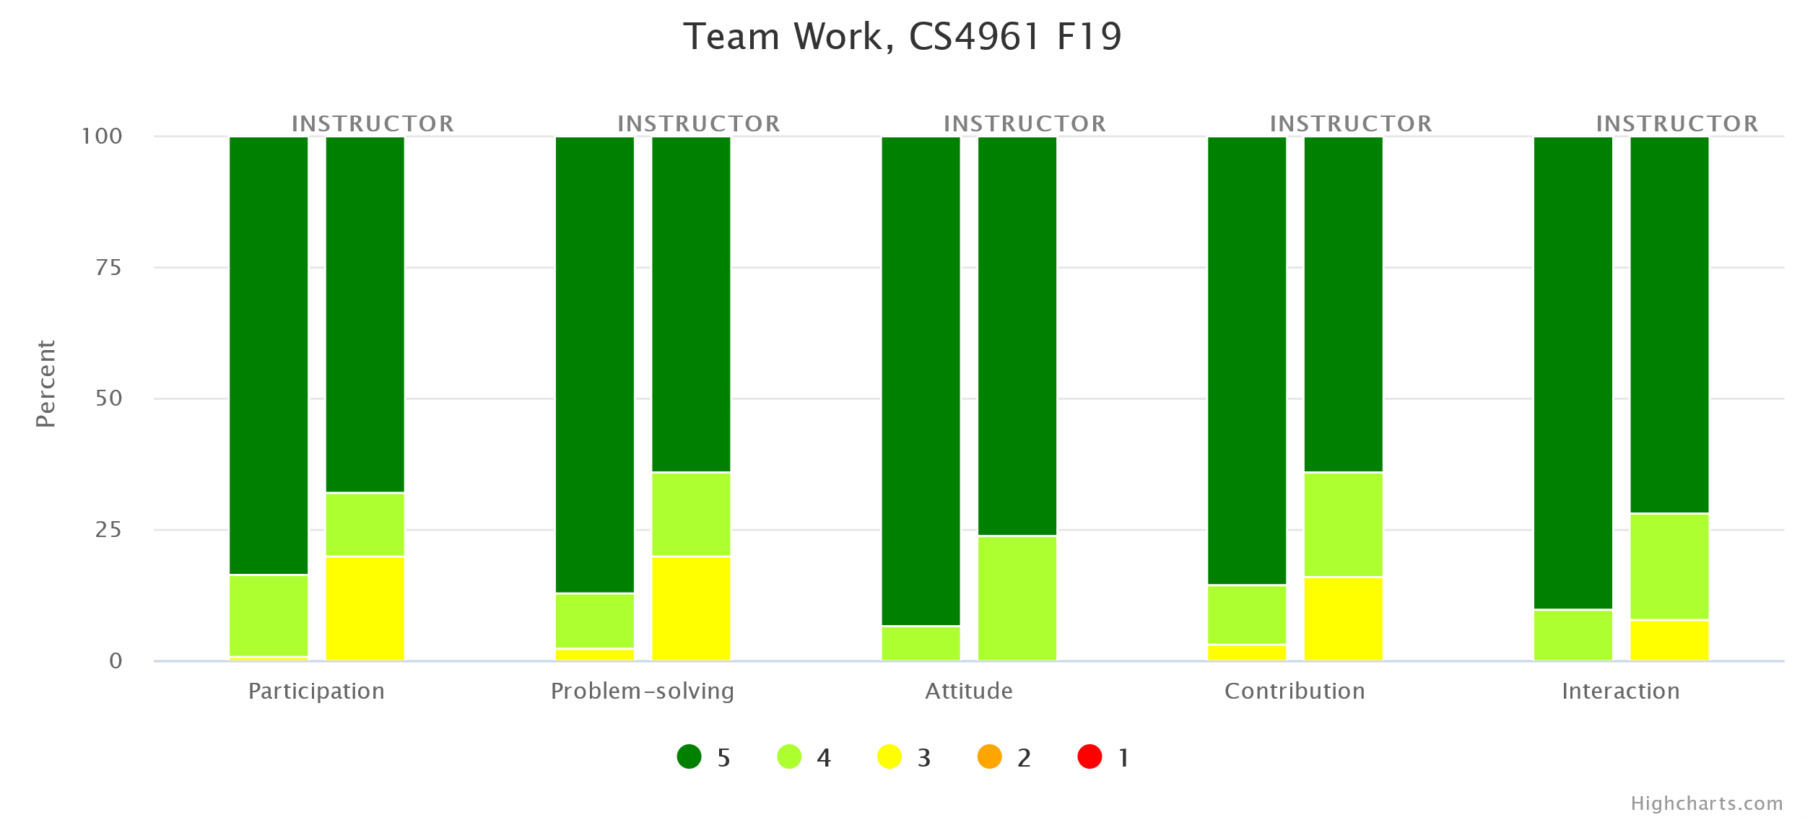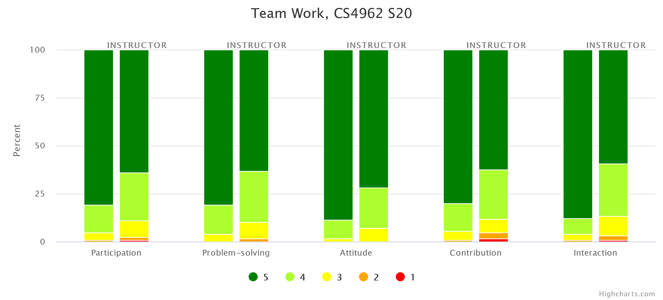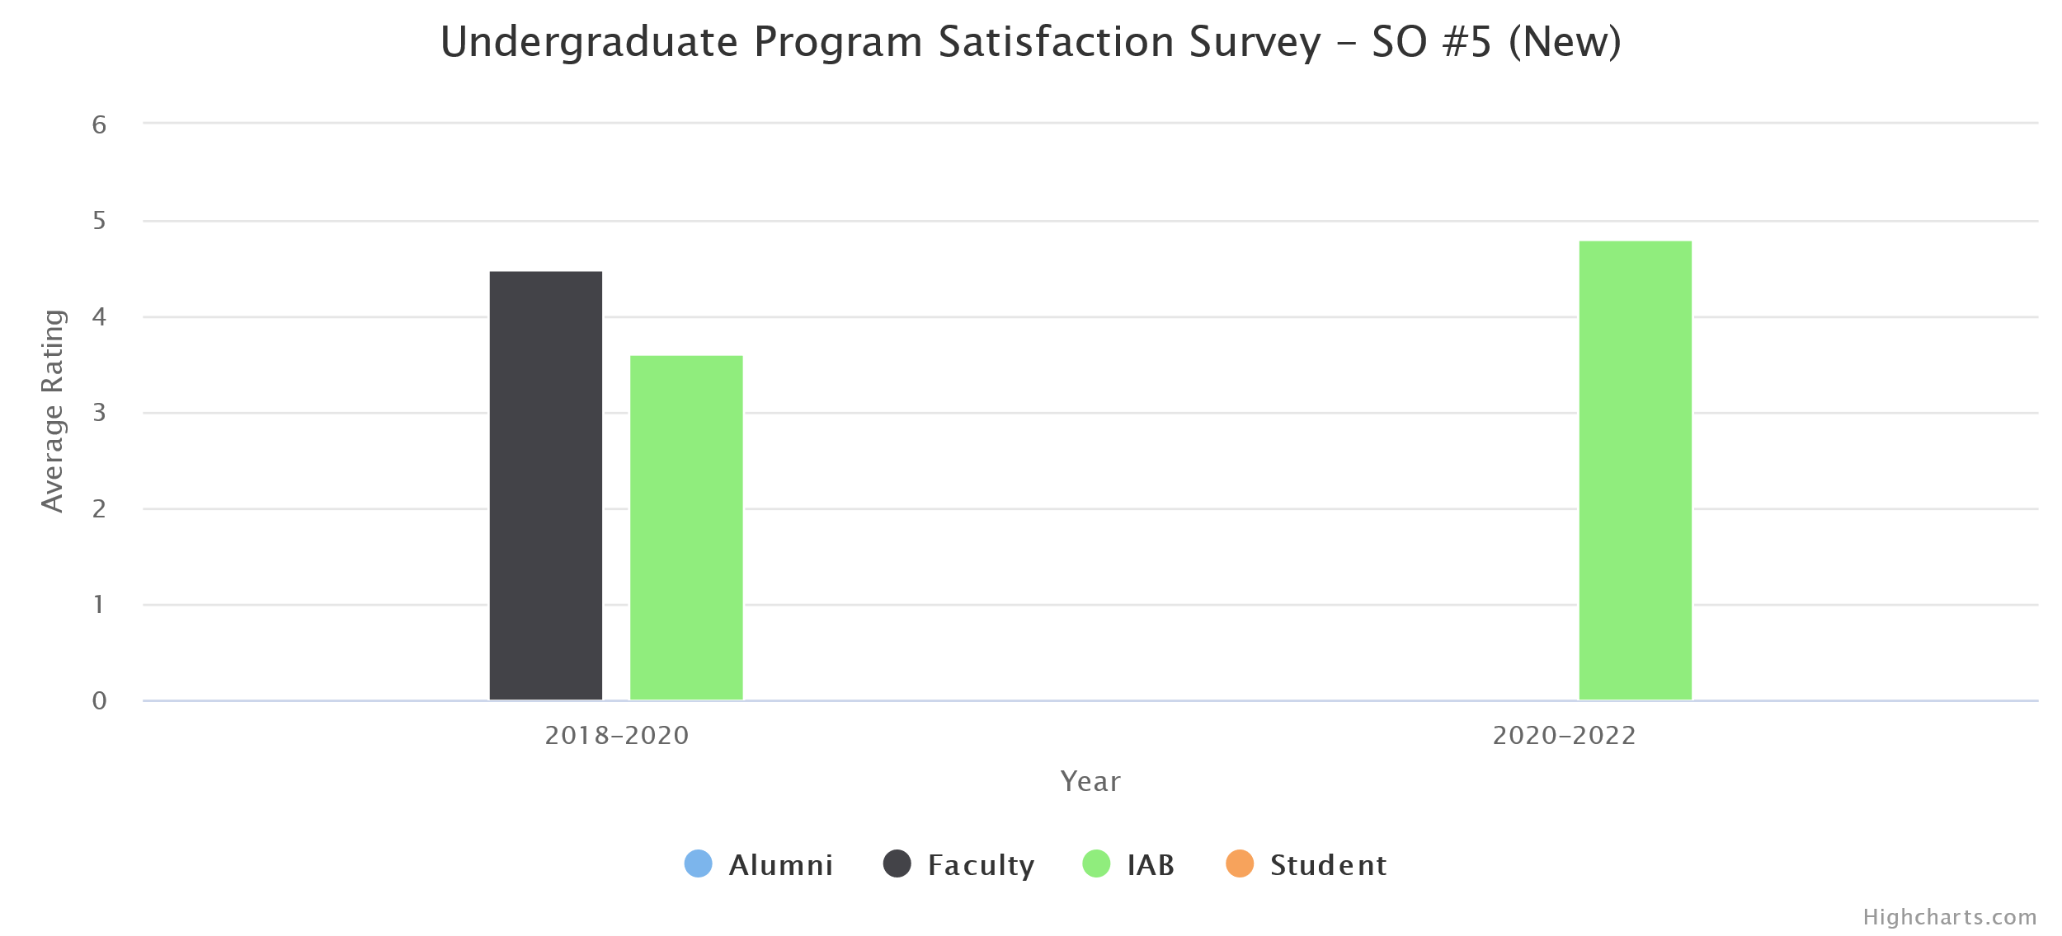
(d) Changes Made
No instructional, programmatic, or curricular changes were made as both rubric assessment and the survey results met our target thresholds.
- Apply computer science theory and software development fundamentals to produce computing-based solutions.
(a) Assessment Measures
- Rubric: Knowledge Outcomes (Ver 2.0) (in CS 4963)
- Survey
- Major Field Test (MFT)
(b) Dates of Assessment
- Rubric: Knowledge Outcomes (Ver 2.0)
  - Spring 2020 in CS 4963
- Survey: Fall 2019
- MFT: Spring 2020
(c) Assessment Results
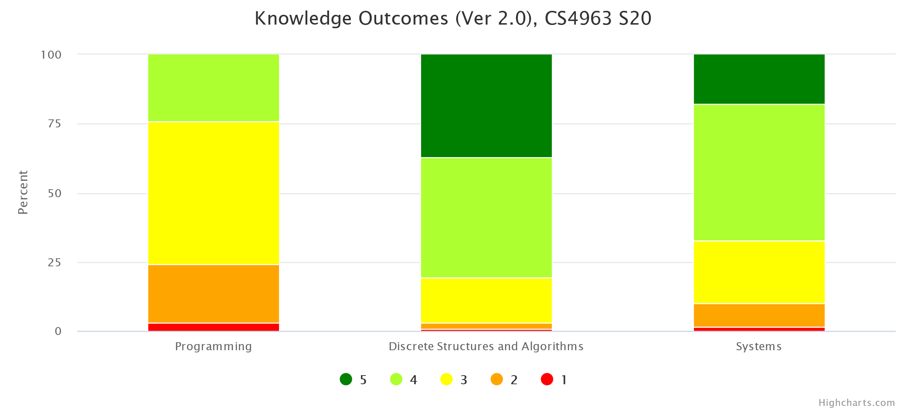
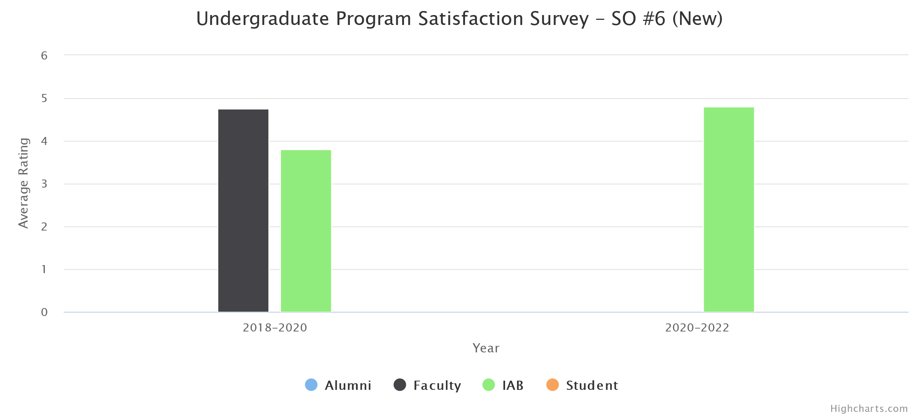
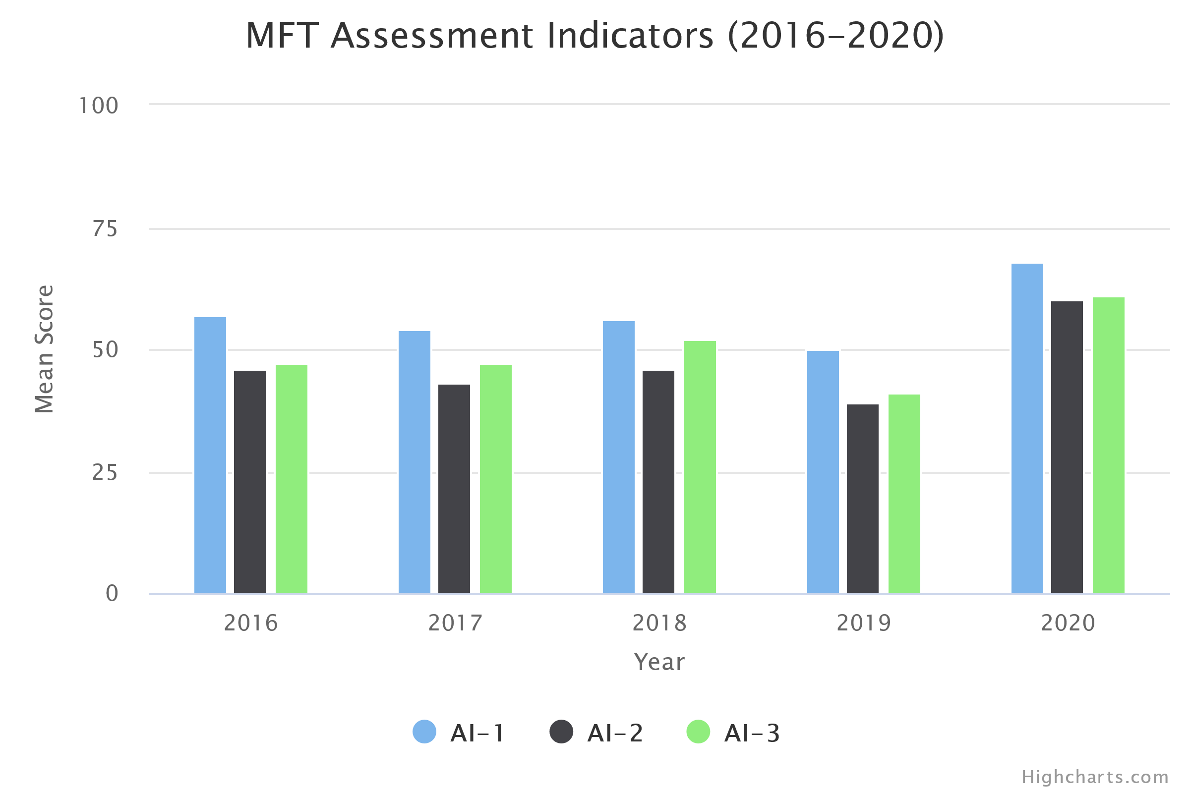
(d) Changes Made
No instructional, programmatic, or curricular changes were made as both rubric assessment and the survey results met our target thresholds.

Other Program-Level changes made or under consideration

A few curricular changes are necessitated by the new Outcomes and new curricular requirements. Faculty and IAB have ratified the changes in Fall 2019. We have submitted all the modification proposals early Fall 2020. The new curricular requirements will be effective Fall 2021 semester term.
- Develop new courses (CS2445 and CS2470) to be added to the program requirements.
- Delete PHYS2200, EE3445, Modification and MATH elective from the program requirements.
General Education and Service Course Assessment
GE/Course Learning Outcome | GELOs assessed in 2019-20 | How and when was this PLO was assessed? (For example, which assessments were used, which courses were examined, what were the dates of data collection?)
GELO1: Knowledge: Mastery of content and processes of inquiry

GELO2: Proficiency: Intellectual skills

GELO3: Place and Community: Urban and global mission

GELO4: Transformation: Integrative learning

Who conducts assessment activities (planning, data collection, etc.) for this program? (Please check all that apply)
faculty who teach courses in the program the program director or department chair
a department or program committee program staff students
Other (please specify) Department Assessment Coordinator

With whom do you share your assessment information? (Please check all that apply)
faculty in the department students in the program campus administrators
department alumni employers external community members
Other (please specify) Industry Advisory Board (IAB)

Impact of COVID 19 - In this section, please provide the challenges faced, addressed with respect to ensuring continued student learning and ensuring the PLOs/SLOs were met.

PLOs | Related Student/Faculty Challenges | Step taken and/or modification made to address the changes
1.
2.
3.
4.
5.
- For remote teaching, instructors have been utilizing CSNS (in-house Course Management System), Canvas, Zoom, YouTube, and Camtasia extensively. Some instructors also use Discord to facilitate communications among students.
- Most Computer Science instructors are very familiar with online teaching tools and quickly adapt to new technology. A couple of faculty needed extra help to get familiar with Canvas and Zoom and they were provided additional resources.
- Instruction-related surveys were conducted more frequently to assess students' online readiness for different situations such as lectures, exams, presentations, and group projects.
- In many programming-heavy courses, traditional exams have been converted to programming projects and take-home exams.
- Several instructors have explored online books or online programming lab tools provided by publishers.
- In Summer 2020, nineteen CS faculty completed the Alt Instruction Summer Institute and converted their course materials and teaching pedagogy to be more suitable for remote teaching. In Fall 2020, two CS faculty have been participating in the CETL's DOC (Designing Online Courses) Certificate program.
******

