California State University, Los Angeles
Annual Assessment Report: Graduate Degree Programs

Program: COMPUTER SCIENCE MASTER OF SCIENCE
Report Semester/Year: FALL 2020

College/School: ECST Assessment Coordinator: DR. CHENGYU SUN

Specialized Accreditation: No Yes please specify Agency/organization and Date _____________________

Department Mission:
To graduate well educated computer scientists who are prepared to meet the challenges of a rapidly changing, increasingly complex world. This will be accomplished through:
- A well-qualified faculty who care about students and their success.
- A dynamic, up-to-date curriculum that has an optimal balance between theory and practice.
- Laboratories, computer facilities, and instructional classrooms on par with any computer science program in the nation.
- Unique co-curricular opportunities for students such as participation in student design competitions, professional student organizations, and pre-professional employment.
- Opportunities for undergraduate and graduate students to participate in research and industry-funded design clinic projects.
- Mutually beneficial partnerships with area industry that take advantage of our location in one of the most concentrated high-tech centers in the nation.
- Strong cooperative relationships with local high schools, community colleges, and with other four-year institutions.

Year revised: 2005

Program Learning Outcomes (PLOs):
Please list all the PLOs and when they were last assessed or plan on being assessed (see attached reference sheet for a rubric with PLO guidelines):
PLOs | When did you last assess it or plan on assessing it?
- Students will have the ability to write and analyze sophisticated algorithms. | Fall 2019
- Student will have the ability to design, develop, and analyze complex software systems. | Fall 2019
- Students will have acquired advanced knowledge and skills in one or more areas of computer science. | Fall 2019
- Students will be able to communicate effectively both orally and in writing. | Fall 2019

Alignment of Institutional Learning Outcomes (ILOs) and PLOs:
Please indicate which of your PLOs best match the following ILOs. (see attached reference sheet for a complete description of each ILO).
Cal State LA Institutional Learning Outcomes:  Graduate | PLO(s) which match this ILO
1. Demonstrate mastery of major theories, concepts, approaches to inquiry and/or practices | 2
2. Demonstrate information literacy | 1
3. Identify and evaluate diverse perspectives, assumptions, and conventions | 2
4. Critically examine quantitative and/or qualitative evidence in the evaluation, construction, and communication of arguments | 2
5. Demonstrate communicative fluency | 4
6. Articulate how advancing knowledge or practice in their field of study contributes to the public good | 2,3
7. Frame and examine a controversy or problem through research, projects, papers, exhibits, or performances | 1,2,3
8. Situate the field of study and its relevance within a broader context, including – but not limited to- social, intellectual, and/or applied professional contexts. | 1,2
9. Apply appropriate ethical standards or practices | 3

Assessment Results
Describe any assessment activities conducted in AY 2019-20 for each outcome. See attached reference sheet for examples of assessment measures and use of results, and rubrics which will be used to evaluate your assessment processes. Please attach any additional information as needed.
Program Learning Outcome  (List activities for each PLO. Enter “general” for activities that pertain to multiple PLOs) | 1. How and when was this PLO assessed? (For example, which assessments were used, which courses were examined, what were the dates of data collection?) See Reference sheet for other examples | 2. What were the results? (For example, how many students reached each level of proficiency on the SLOs assessed?) See Reference sheet for other examples | 3. Based on the results, what instructional, programmatic, or curricular improvements were made?
- Students will have the ability to write and analyze sophisticated algorithms.
(a) Assessment Measures
- Rubric: Program Development and Description (in CS 5690 and CS 5990)
- Survey
(b) Dates of Assessment
- Rubric: Program Development and Description
  - Fall 2019 in CS 5690, CS 5990
- Survey: Fall 2019
(c) Assessment Results
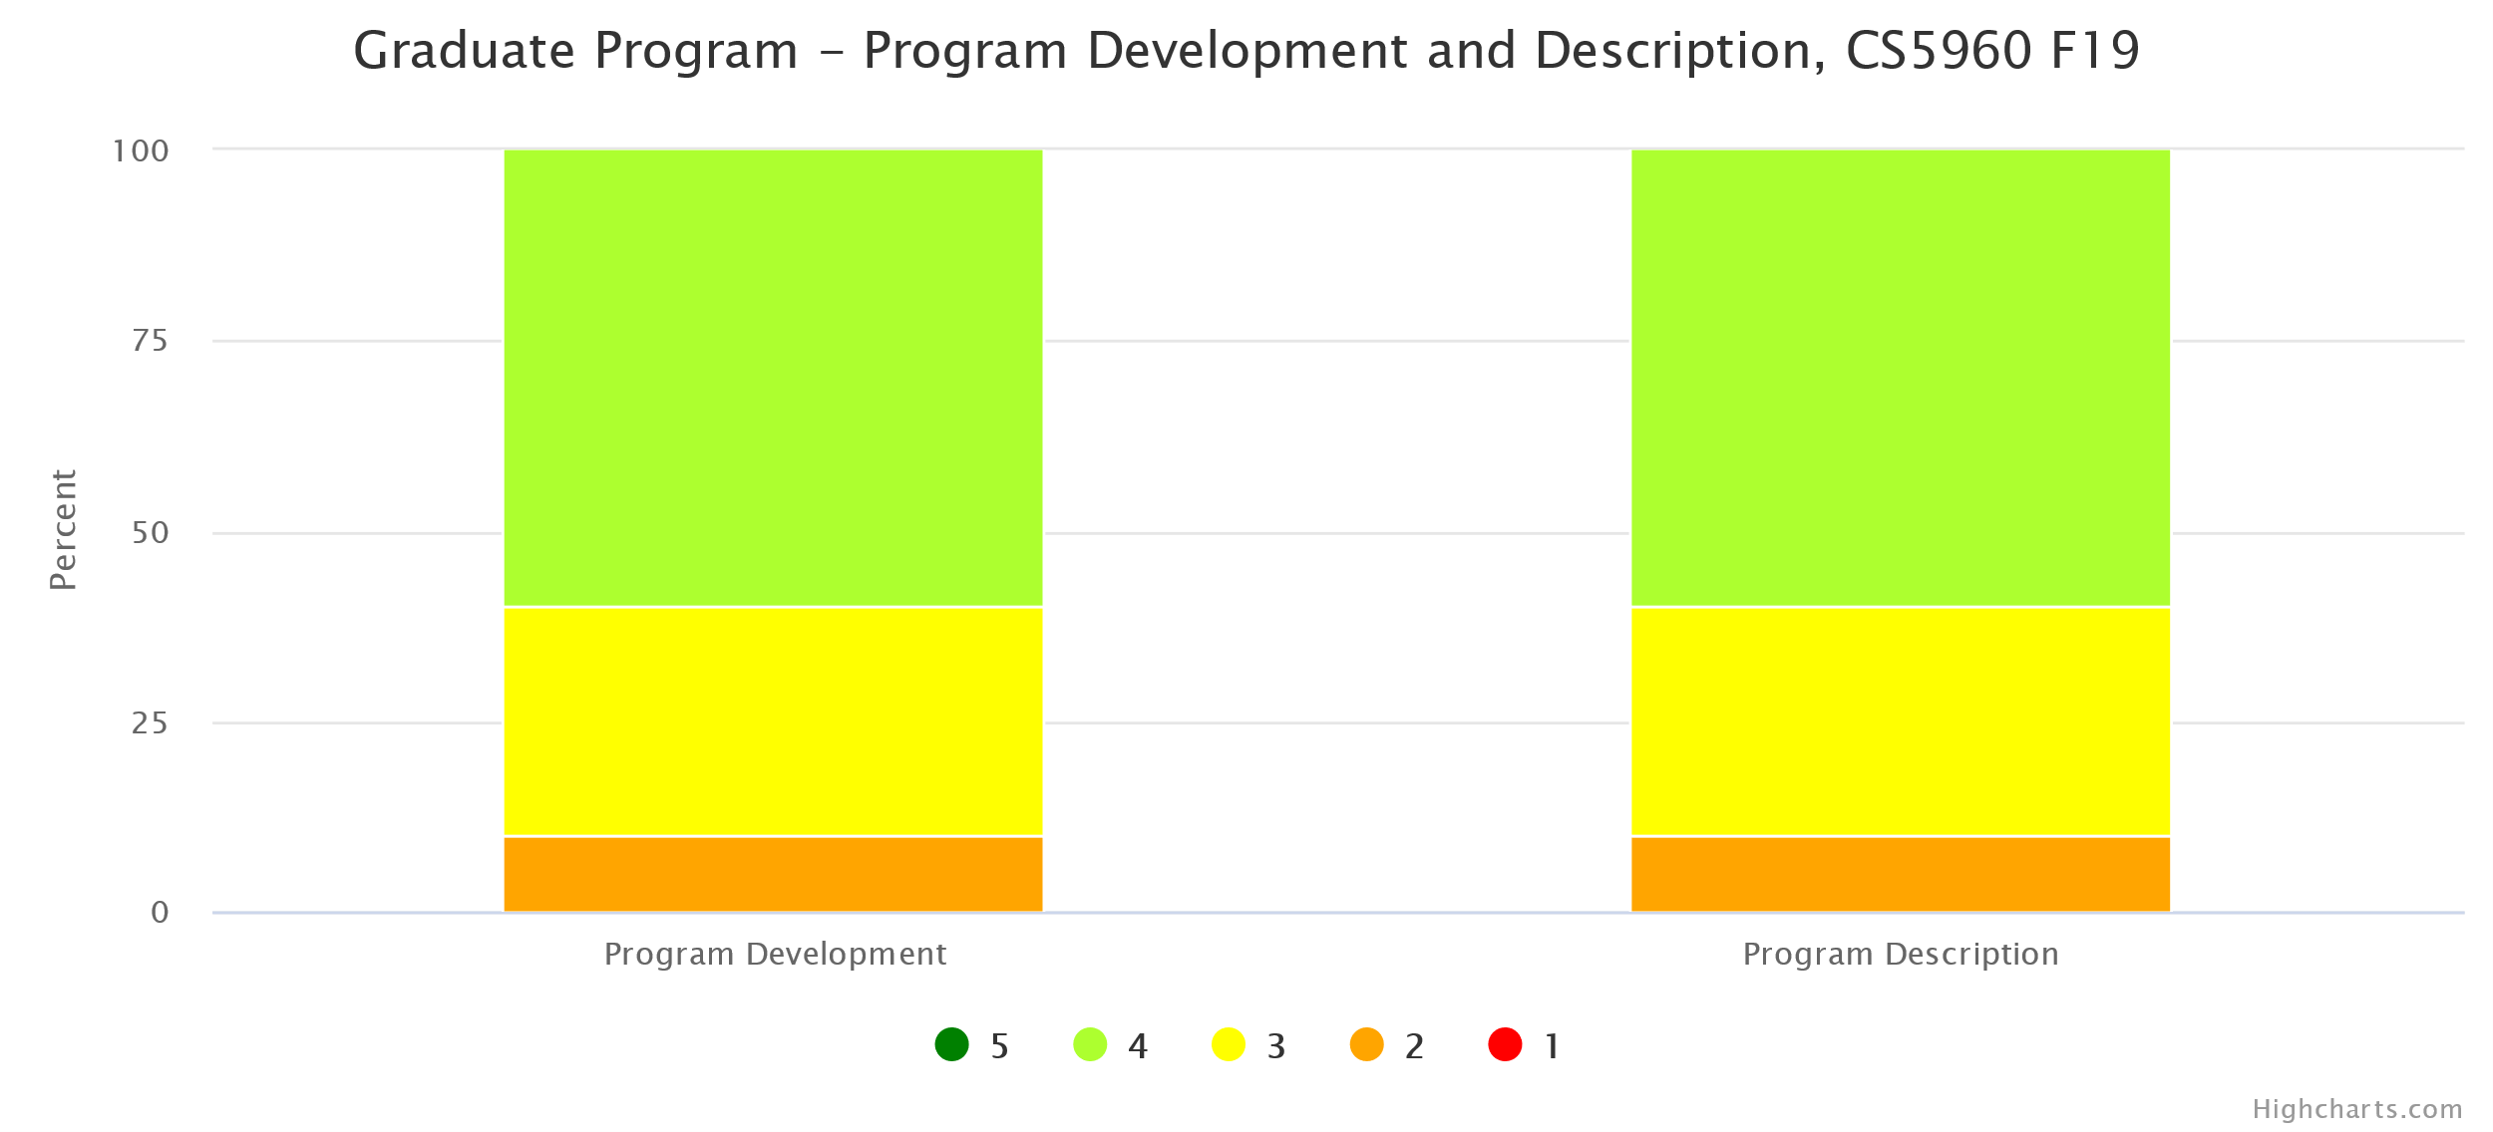

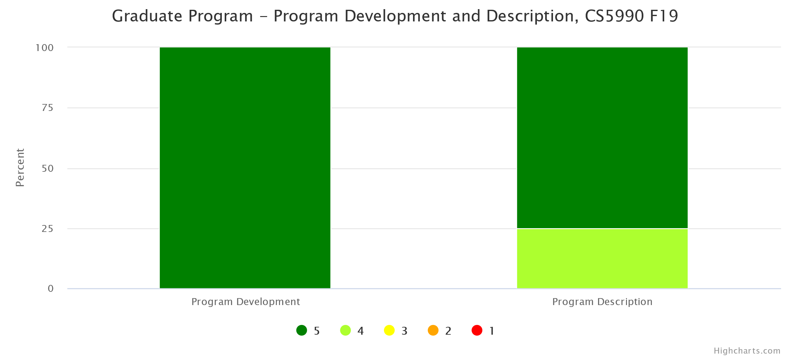

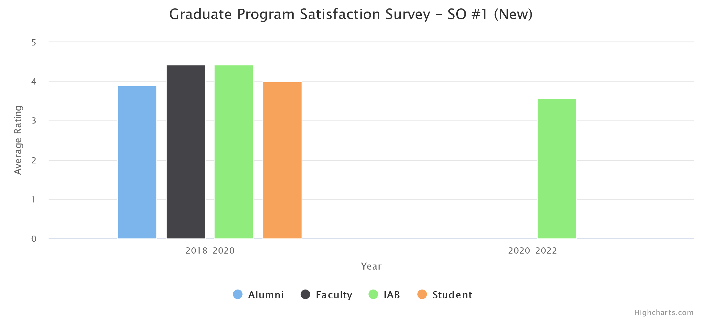
(d) Changes Made
No instructional, programmatic, or curricular changes were made as both rubric assessment and the survey results met our target thresholds.
2. Student will have the ability to design, develop, and analyze complex software systems.
(a) Assessment Measures
- Rubric: Software Design and Implementation (in CS 5220 and CS 5990)
- Survey
(b) Dates of Assessment
- Rubric: Software Design and Implementation
  - Fall 2019 in CS 5990
- Survey: Fall 2019
(c) Assessment Results

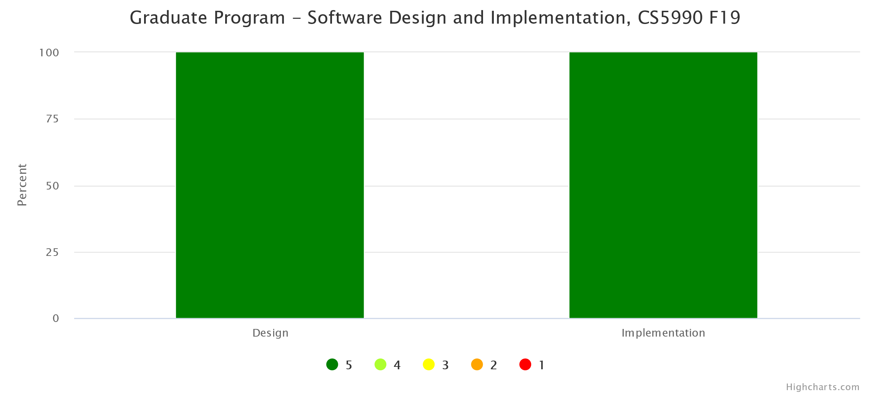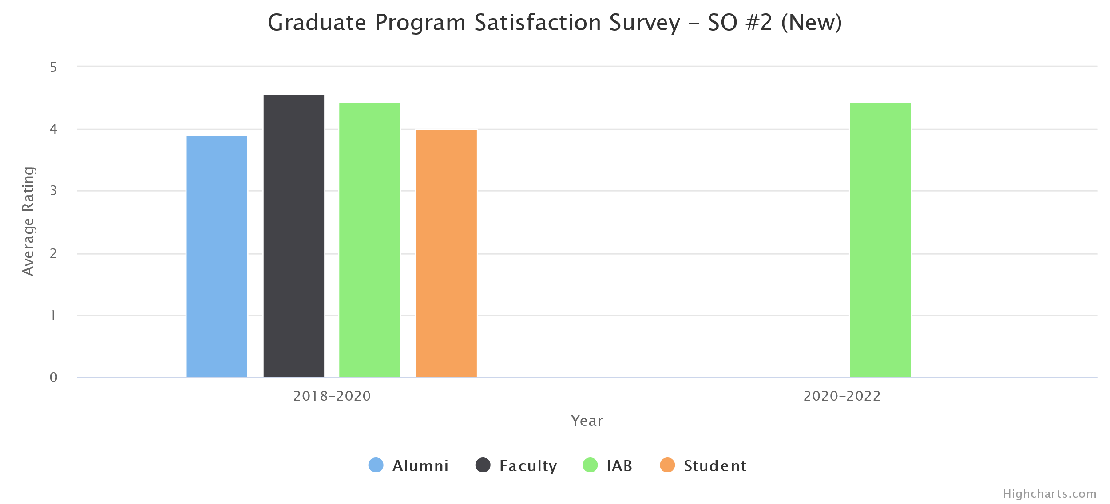

(d) Changes Made
No instructional, programmatic, or curricular changes were made as both rubric assessment and the survey results met our target thresholds.
3. Students will have acquired advanced knowledge and skills in one or more areas of computer science.
(a) Assessment Measures
- Rubric: Competency in Advanced Areas (in CS 5960 and CS 5990)
- Survey
(b) Dates of Assessment
- Rubric: Competency in Advanced Areas
  - Fall 2019 in CS 5960, CS 5990
- Survey: Fall 2019
(c) Assessment Results
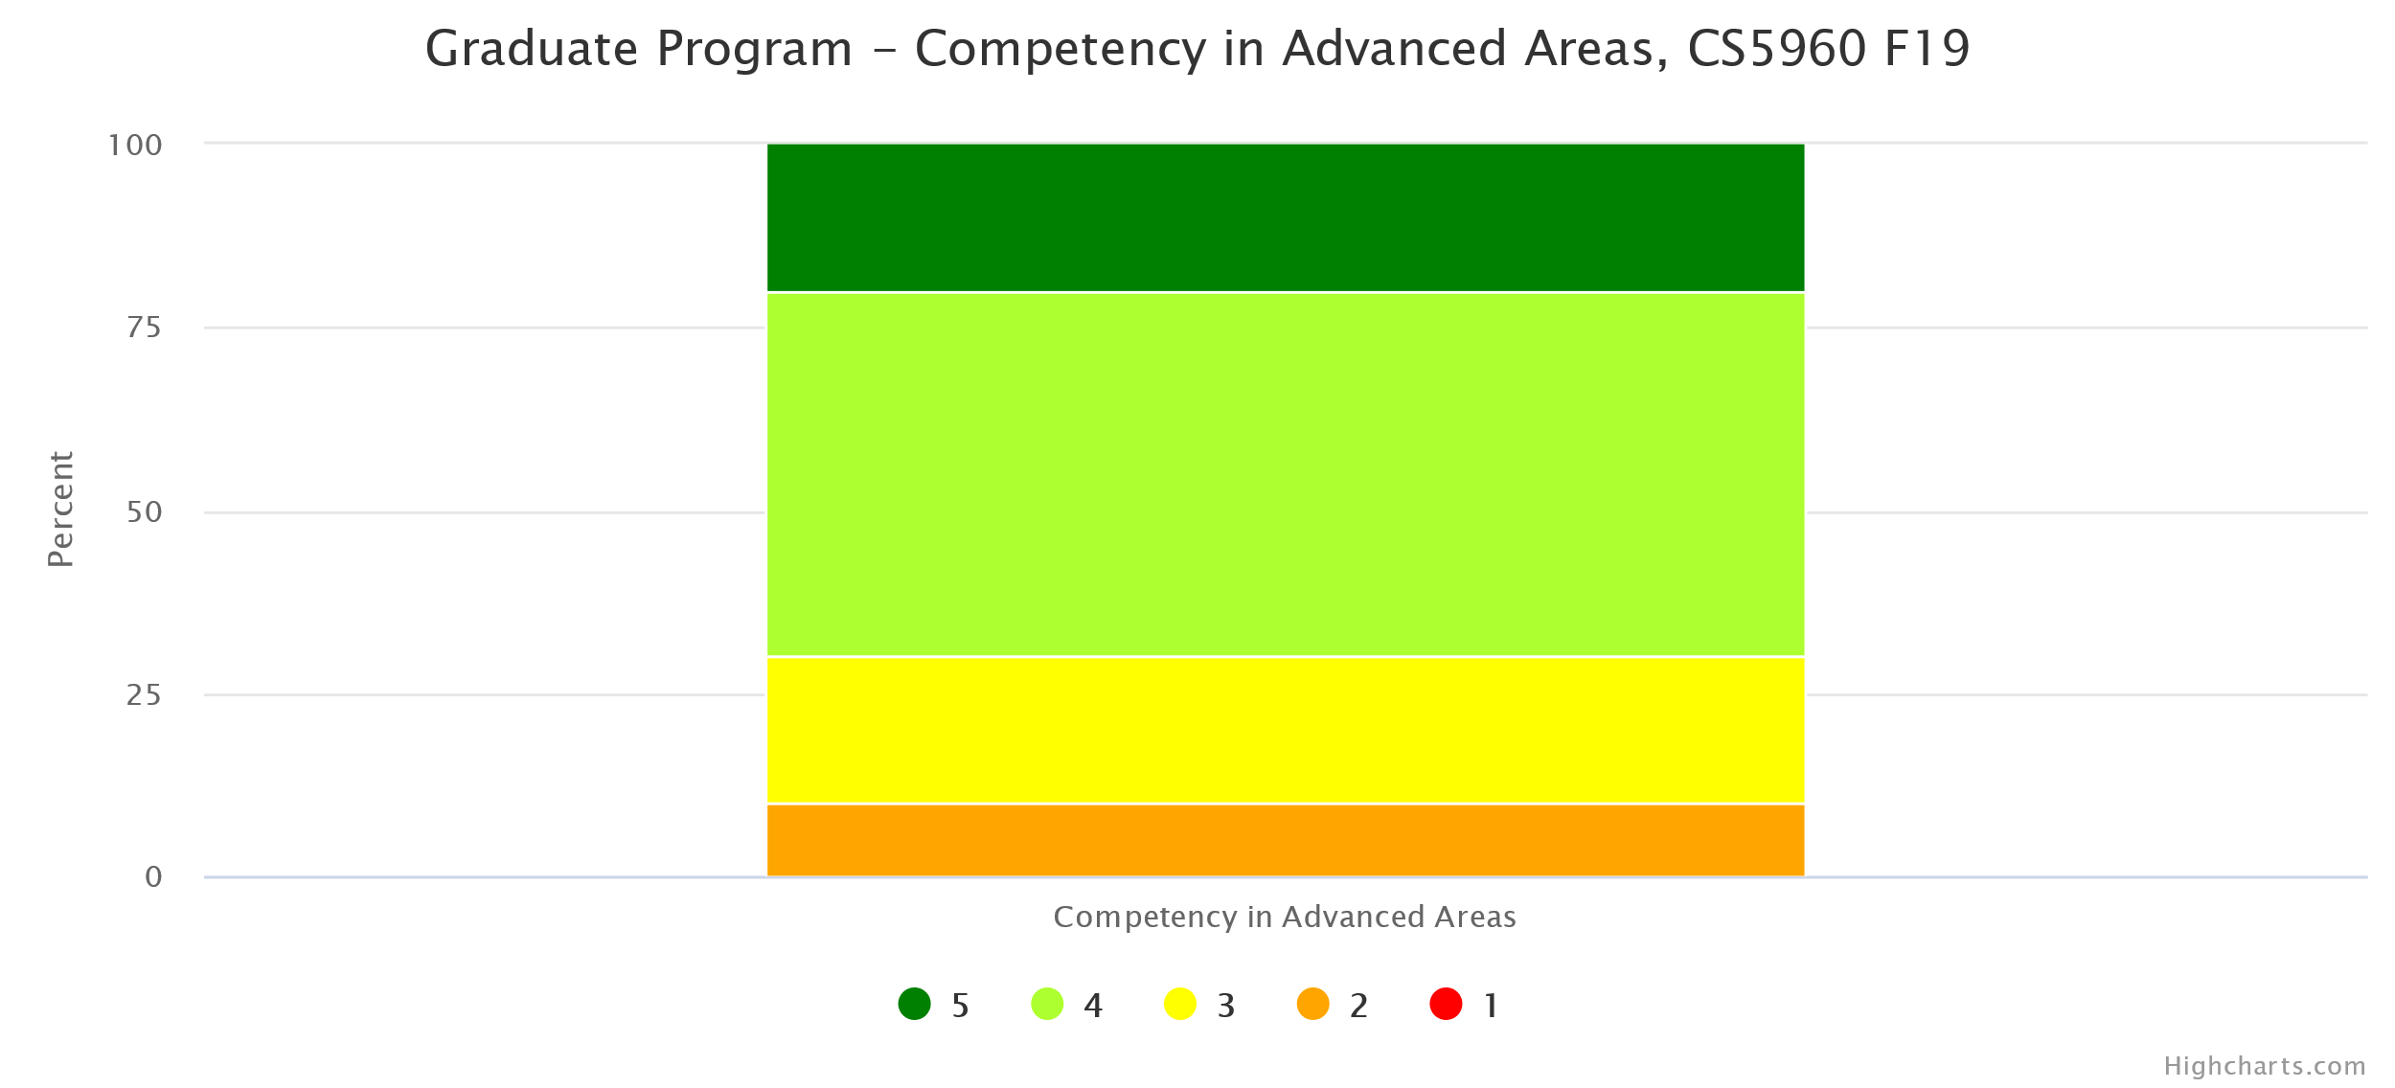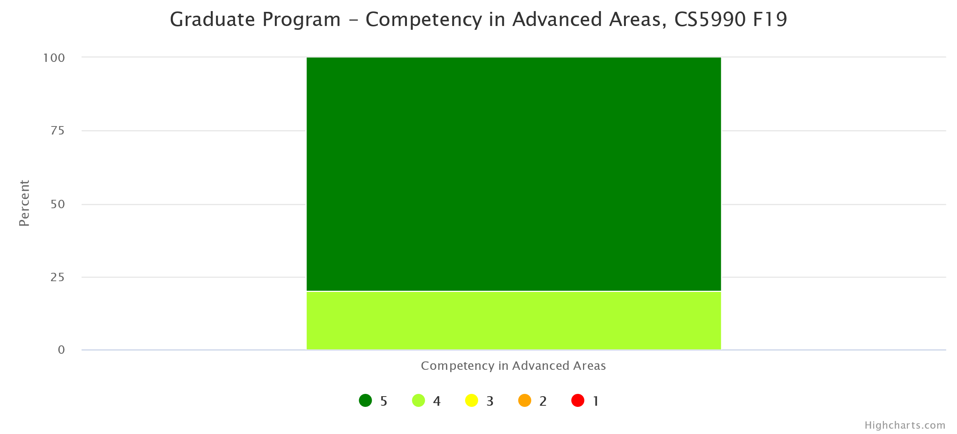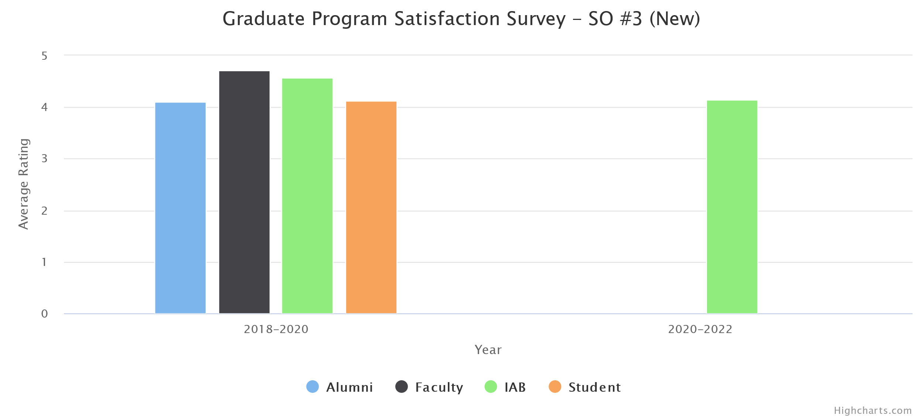
4. Students will be able to communicate effectively both orally and in writing.
(a) Assessment Measures
- Rubric: Oral Communication (in CS 5990)
- Rubric: Written Communication (in CS 5990)
- Survey
(b) Dates of Assessment
- Rubric: Oral Communication
  - Fall 2019 in CS 5990
- Rubric: Written Communication
  - Fall 2019 in CS 5990
- Survey: Fall 2019
(c) Assessment Results
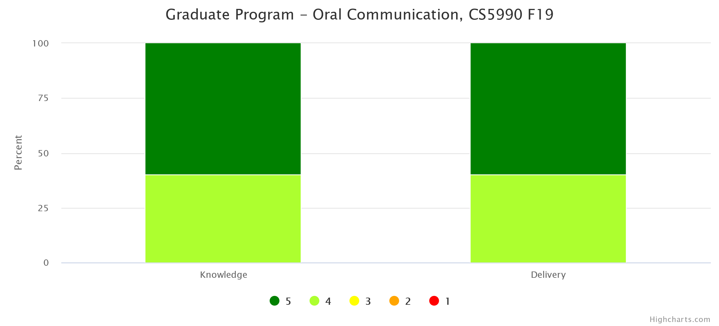
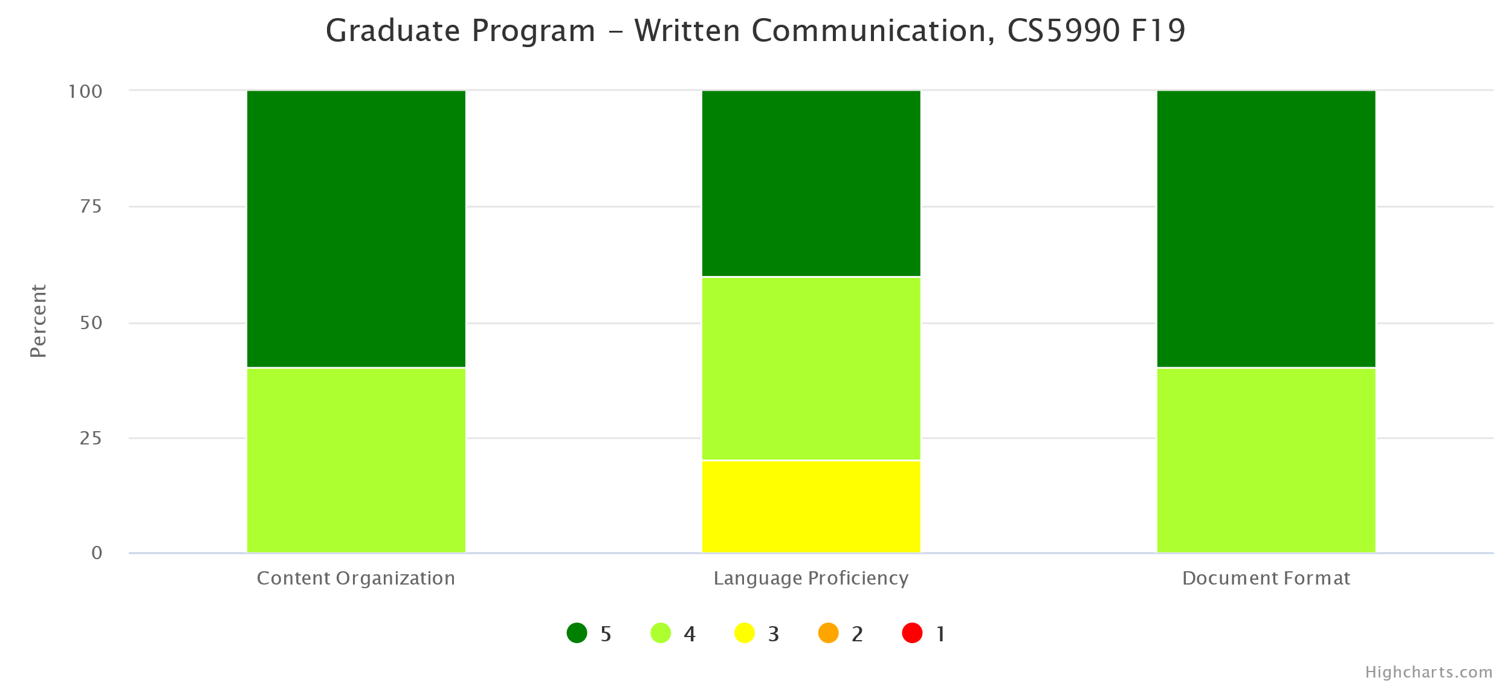
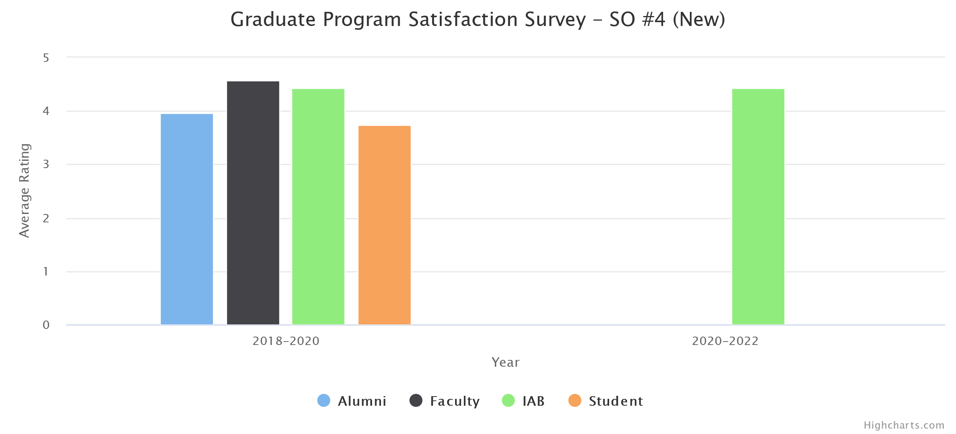

Other Program-Level changes made or under consideration
Program modification to be compliant with EO 1017.

Who conducts assessment activities (planning, data collection, etc.) for this program? (Please check all that apply)
faculty who teach courses in the program the program director or department chair
a department or program committee program staff students
Other (please specify) Department Assessment Coordinator
With whom do you share your assessment information? (Please check all that apply)
faculty in the department students in the program campus administrators
department alumni employers external community members
Other (please specify) Industry Advisory Board (IAB)

Impact of COVID 19 - In this section, please provide the challenges faced, addressed with respect to ensuring continued student learning and ensuring the PLOs/SLOs were met.

PLOs | Related Student/Faculty Challenges | Step taken and/or modification made to address the changes
1.
2.
3.
4.
5.
- For remote teaching, instructors have been utilizing CSNS (in-house Course Management System), Canvas, Zoom, YouTube, and Camtasia extensively. Some instructors also use Discord to facilitate communications among students.
- Most Computer Science instructors are very familiar with online teaching tools and quickly adapt to new technology. A couple of faculty needed extra help to get familiar with Canvas and Zoom and they were provided additional resources.
- Instruction-related surveys were conducted more frequently to assess students' online readiness for different situations such as lectures, exams, presentations, and group projects.
- In many programming-heavy courses, traditional exams have been converted to programming projects and take-home exams.
- Several instructors have explored online books or online programming lab tools provided by publishers.
- In Summer 2020, nineteen CS faculty completed the Alt Instruction Summer Institute and converted their course materials and teaching pedagogy to be more suitable for remote teaching. In Fall 2020, two CS faculty have been participating in the CETL's DOC (Designing Online Courses) Certificate program.
******

